 | Oregon Department of Transportation
 | Transportation Application Development
 | TransInfo Signs Asset Data Integration Project
P219S Software Architecture
Version v2b1

Jesse Day

Name Of Person Responsible For Change | Date Of Revision | Reason For the Change and Short Summary of the Revisions Made | Version Number
Jesse Day | 11/5/14 | First Bentley draft, Access DBA/Programmer Input | v2b1
Gwynn Coffman | 11/13/14 | Merged Draft | v2b2

Contents
1. Overview 4
1.1 Software Architecture Model Diagrams 4
1.1.1 Toughbook / User PC Sync Process Diagram 4
1.1.2 Bentley Sync Broker Diagram 5
2. Architectural Layer Descriptions 6
2.1 Crew Sync Tool 6
2.2 Sync Exception Reporting for Crew and Sign Asset Management 6
2.3 Back-end 6
2.4 Database - Access 7
2.5 Database – Oracle (for TransInfo) 7
3. Data Modeling 8
3.1.1 Access Data Modeling 8
3.1.2 TransInfo Data Modeling 8
4. Software Distribution 9
5. Configuration Management & Control 10

Overview

Software Architecture Model Diagrams

Toughbook / User PC Sync Process Diagram
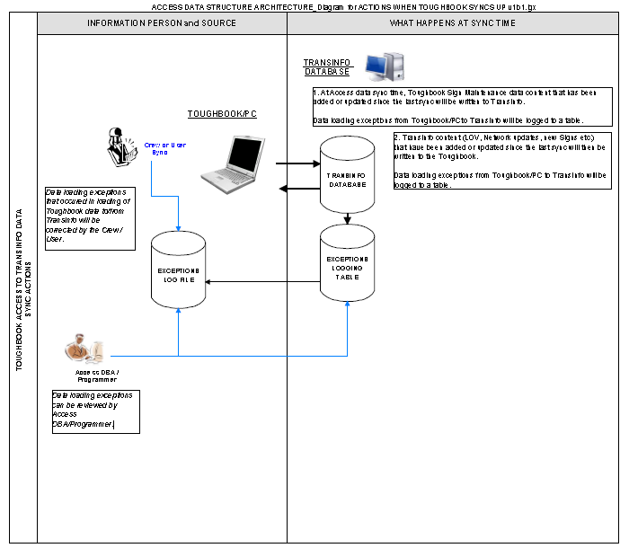
Diagram 1.1.1

Bentley Sync Broker Diagram

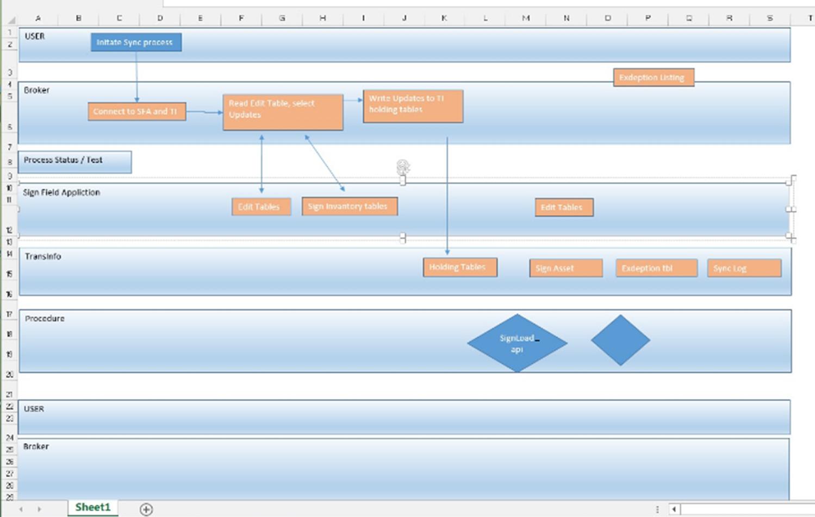

Diagram 1.1.2

Architectural Layer Descriptions

Crew Sync Tool

Platform
Panasonic Toughbook Model CF-19
Processor: Intel® Core™ i5-3320M CPU @ 2.60Ghz
Installed Memory (RAM): 4.00GB
System Type: 64-bit Operating System
500GB HD
Windows 7
Office 2010

The sync tool will run on any similarly configured computer with the installed signs field data base and required (to be determined) software components.

Tool/Method
- VB.NET 2008
- .NET Com objects will communicate (Read and Write) directly with Access database
- Oracle Data Provider for .NET (ODP.NET) will communicate (Read– *need to verify licensing for distribution to Toughbook/User PCs

Sync Exception Reporting for Crew and Sign Asset Management

Broker Platform
See section 2.1.1.1

Tool/Method
- Exception data will be written to an exception table in an yet to be determined location (in either the EXOT Oracle database instance or other Oracle/SQL server instance)
- Sync tool com objects will write exception listing to Word Pad or NotePad

Back-end

Platform
TransInfo Oracle database

Tool/Method
Oracle packages, procedurals and functions

Database - Access

Platform
Desktop/Toughbook / User PC

Tool/Method
Microsoft Access2010

Database – Oracle (for TransInfo)

Platform
Dedicated Oracle Server

Tool/Method
Data stored in database which will be created and maintained using Oracle vxxx

Data Modeling

Access Data Modeling

Platform
Toughbook/User PC Access

Tool/Method
Access 2010

TransInfo Data Modeling

Platform
Oracle

Tool/Method
Sybase PowerDesigner Data Architect v9.0

Software Distribution

Platform
NA

Tool/Method
- Downloadable installer, installed on Toughbook/User PC
* will need to verify if Installer can be installed and used without Toughbook/PC Administrator rights

Configuration Management & Control

Platform
Toughbook/Desktop Access Schema and Forms

Tool/Method
The Application is built using Access and managed by Access DBA/Programmer. Access database schema changes will be managed in conjunction with ODOT TAD’s Change Management process.

Platform
TransInfo Asset Data Setup

Tool/Method
xxx. from Charlotte

